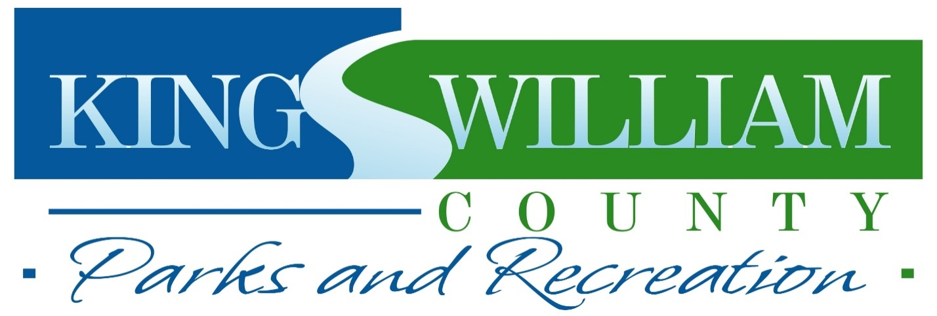
PARENTS: Please sign in acknowledgement of the following policies:
Participation Waiver: I, the undersigned participant/parent or guardian, if under eighteen, desiring to participate in the King William County Parks and Recreation Department programs and all special events, hereby release and agree to indemnify and save harmless King William County, the Parks and Recreation Department, their employees, King William County Public Schools, Town of West Point, West Point Public Schools and any official of the special activity from any and all claims of any nature for injury or loss that may result from such participation or preparation for such participation. I hereby fully consent to emergency medical care rendered by competent personnel or hospitals, should such attention become necessary during the event. Further, I certify that the entrant is in good physical condition and capable of participating in programs.

Publicity Waiver: I hereby fully consent to allow King William County Parks and Recreation to use photographs taken during this program for publicity purposes.

Child/Children’s Name in the Program: ______________________________________________

Participant or Parent/Guardian Signature: __________________________________________Date:___________________

